Assignment -15

Batch: 37
Roll No: 2303A2317

Task Descriptor-1: (Setup Fast API Backend )
Instructions:
• Install Fats tAPI and Uvicorn.
• Use AI to generate a basic FastAPI application with one endpoint
Sample Code: from fastapi import FastAPI app = FastAPI()
@app.get("/") def read_root():
return {"message": "Welcome to AI-powered FastAPI"}
Expected Output:
Running the server and accessing:
http://127.0.0.1:8000/
Response:
{"message": "Welcome to AI-powered FastAPI"}
Prompt:-
Generate a simple FastAPI application in Python.
Requirements:
- Import FastAPI
- Create FastAPI app
- Create one GET endpoint "/"
- The endpoint should return JSON message:
{"message": "Welcome to AI-powered FastAPI"}
The code should run using uvicorn and be beginner friendly.

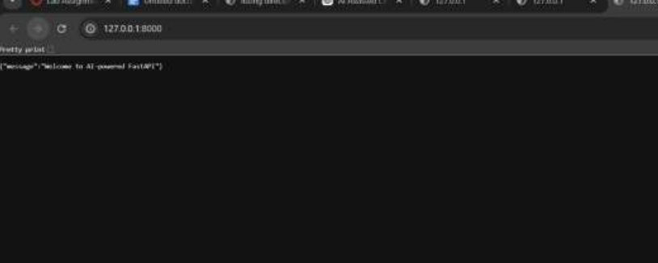
Output:-Task Descriptor- 2: (API – Create and Read Items) Instructions:
• Implement endpoints to add and retrieve products.
• Use a Python list as temporary storage.
Sample Code: items = []
@app.get("/items") def
get_items(): return
items
@app.post("/items") def
add_item(item: dict):
items.append(item)
return {"message": "Item created", "item": item} Expected
Output:
GET /items → []
POST /items with {"name":"Pen","price":20}
→ {"message":"Item created","item":{"name":"Pen","price":20}}
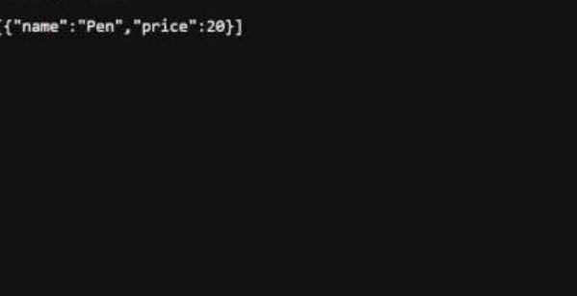

Task Descriptor- 3: (Update Existing Item) Instructions:
• Use AI to generate an endpoint to update an item using its index.
Sample Code:
@app.put("/items/{index}") def
update_item(index: int, item: dict): if
index >= len(items): return {"error":
"Item not found"} items[index] = item
return {"message": "Item updated", "item": item} Expected
Output:
PUT /items/0 with {"name":"Pencil","price":10}
→ {"message":"Item updated","item":{"name":"Pencil","price":10}}

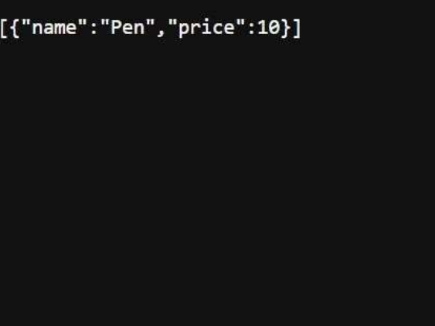

Task Descriptor- 4: (Delete Item) Instructions:
• Implement deletion of an item by index. Sample Code:
@app.delete("/items/{index}") def delete_item(index: int): if index
>= len(items):
return {"error": "Item not found"} removed
= items.pop(index)
return {"message": "Item removed", "item": removed} Expected
Output: DELETE /items/0
→ {"message":"Item removed","item":{"name":"Pencil","price":10}}
Task Descriptor -5: (Add Auto-Generated Documentation)
Instructions:
• Use AI to add inline comments and docstrings for all endpoints.
• Optionally, integrate Swagger / Flask-RESTX to auto-generate API
documentation.
Sample Code:
@app.route('/items', methods=['GET'])
def get_items(): """
GET /items
Returns a list of all items in the store.
"""
return jsonify(items) Expected
Output:
• Clear documentation for all endpoints, e.g., via /docs if using Swagger.• Students should be able to see endpoint description, methods, and
sample payloads.

